Patterning Semiconductor ‘Building Blocks’ in 2D Crystals

For the first time, researchers have synthesized lateral semiconductor heterojunctions in lithographically patterned arrays within a two-dimensional semiconductor crystal monolayer by a novel process that selectively converted exposed regions of a monolayer of MoSe₂ to MoS₂ using laser-deposited sulfur. The development of a scalable, easily implemented process to lithographically pattern and easily form lateral semiconducting heterojunctions within two-dimensional crystals fulfills a critical need for “building blocks” required to enable next-generation ultrathin devices for applications ranging from flexible consumer electronics to solar energy.
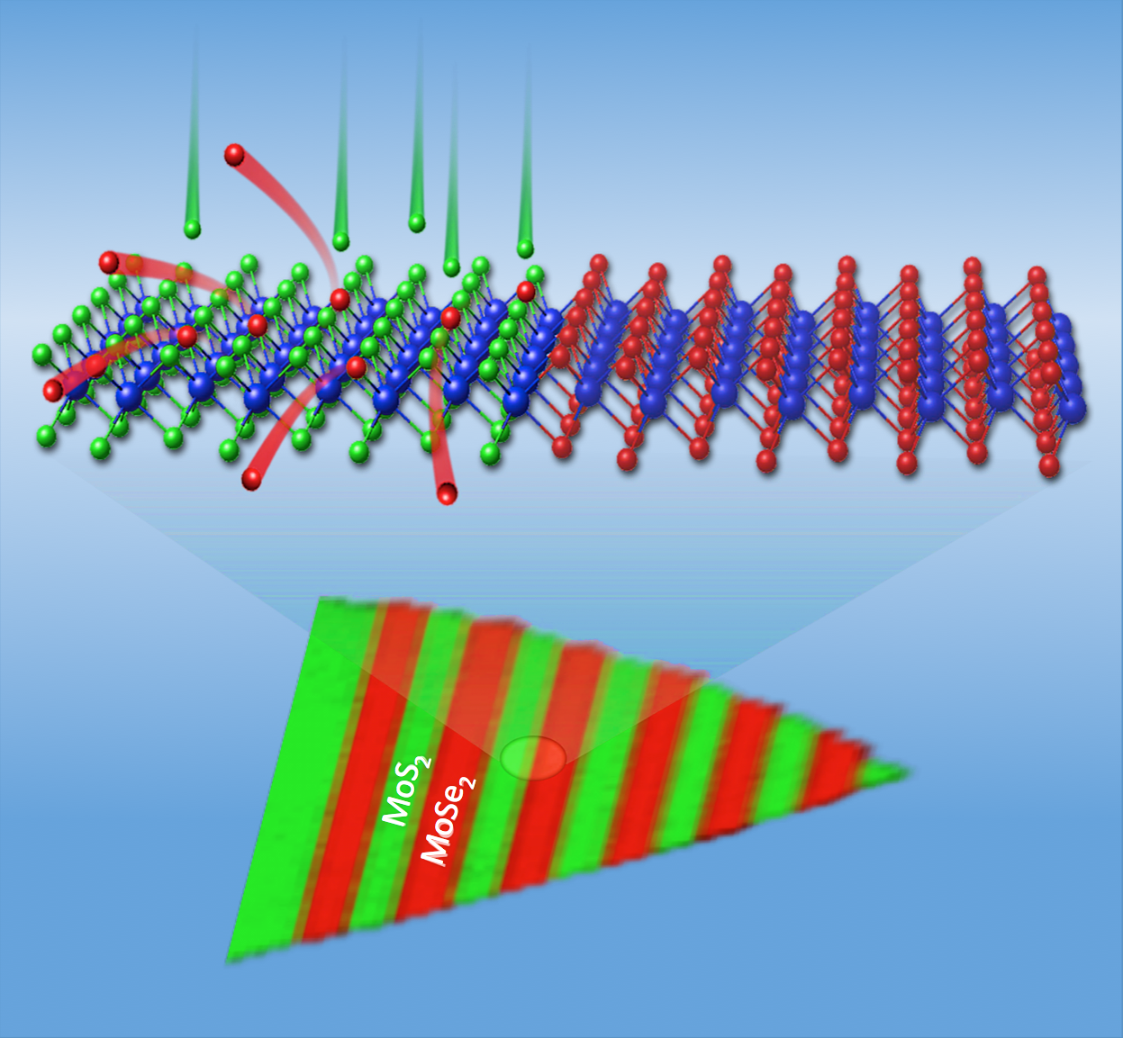Arrays of semiconducting heterojunctions – the building blocks of ultrathin device electronics – were formed for the first time within a two-dimensional crystalline monolayer by lithographic patterning and pulsed laser deposition of sulfur. Sulfur atoms (green) replace selenium atoms (red) to convert MoSe₂ to MoS₂ in lithographically exposed regions (top) as shown by Raman spectroscopic mapping (bottom) of an actual MoSe₂/MoS₂ crystal.
Regions of monolayer molybdenum diselenide crystals were covered by patterns of a protective layer of silicon dioxide that was applied using standard lithography techniques. The exposed regions were rapidly converted to molybdenum disulfide through the replacement of Se by S within the lattice, forming arrays with sharp (~5 nm) MoSe₂/MoS₂ junctions. This work establishes a scalable processing technique to form patterns of semiconductor heterojunctions to enable the next generation of two-dimensional electronic and optoelectronic devices.¹
¹ Masoud Mahjouri-Samani, Ming-Wei Lin, Kai Wang, Andrew R. Lupini, Jaekwang Lee, Leonardo Basile, Abdelaziz Boulesbaa, Christopher M. Rouleau, Alexander A. Puretzky, Ilia N. Ivanov, Kai Xiao, Mina Yoon, and David B. Geohegan, “Patterned Arrays of Lateral Heterojunctions within Monolayer Two-Dimensional Semiconductors,” Nature Communications (2015). DOI: 10.1038/ncomms8749
Synthesis science including crystal growth, in situ plume diagnostics, TEM analysis, SEM and AFM studies, and conversion technique development was supported by the U.S. Department of Energy, Office of Science, Basic Energy Sciences, Materials Sciences and Engineering Division and performed in part as a user project at the Center for Nanophase Materials Sciences, a DOE Office of Science User Facility. Characterization science at CNMS including optical characterization and lithography techniques was supported by the Scientific User Facilities Division. Basile received support from the National Secretariat of Higher Education, Science, Technology and Innovation of Ecuador.

